**Project Summary – Star Identification from Image Application**

Extension of one of the task 1 into a full project and application

**Submitters**

Liron Cohen 312324247

Alon Suissa 211344015

**Name App: Star Identifier**

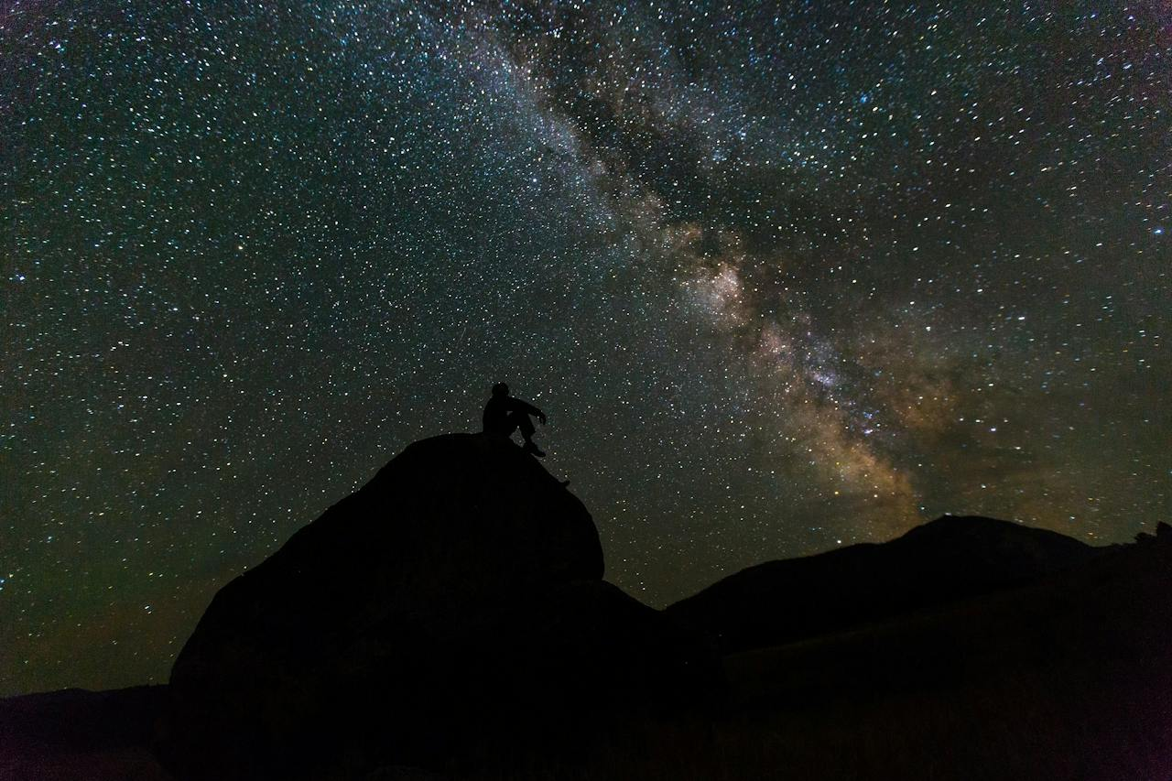

**Project Summary – Star Identification from Image Application**

This project is an Android application that allows you to identify stars in an image using image processing and the astronomical database

**Project Topic:**

Development of an application for identifying stars from an image using a large astronomical database.

**Problem Definition:**

The problem: Star identification in the sky is the process of identifying and re-identifying stars, other celestial bodies, and astronomical observations using data collected from optical systems or other instruments (such as telescopes or cameras). The goal of identification is to locate and map stars in the sky automatically or semi-automatically and to match the information found with existing astronomical information.

Today, both amateur and professional users frequently photograph the night sky, yet they lack simple, accurate, and accessible tools to identify celestial bodies in those images. While real-time star recognition apps (such as **SkyView** or **Star Walk**) exist, they generally do not support recognition from static images and require device sensors (like GPS and compass). Furthermore, they are often closed-source and not easily extendable. Therefore, there is a clear need for a tool that allows users to upload an image and receive accurate star identifications via image processing and comparison with a comprehensive astronomical database.

**Literature Review:**

**Astronomical Databases:-**

Several star catalogs exist that contain data on millions of stars, including:

Gaia, Hipparcos, Sloan Digital Sky Survey (SDSS)  
These databases include details such as celestial coordinates, brightness, and color.

**-Existing Methods for Star Recognition:**

**-Pattern Matching algorithms**: Match star groupings in the image to known constellations or formations.

**-Spherical Coordinate Mapping**: Projects image data into celestial coordinate space.

**-Image Processing with OpenCV**: Used to identify significant light points (stars) by detecting contours and filtering noise.

**-Similar Applications:**

**-Star Walk**, **Sky Map**, **Stellarium** – Mostly real-time, relying on device orientation and location.

**-Astrometry.net** – A web-based tool allowing image uploads for analysis, but not optimized for user experience or broad accessibility.

**Development Plan:**

**Data Collection:**

Use stars from astronomical database.

**Image Processing:**

Use **OpenCV** to detect prominent light points in the image (representing stars).

Perform noise filtering, brightness normalization, and pixel-coordinate extraction of stars.

**Sky Mapping:**

Convert image points to possible celestial coordinates .

Match image patterns with database entries to identify specific stars.

**User Interface:**

Develop a Android application allowing image upload and results display.

Present star names and additional data over the image

Option to create a personal user profile to save preferences

Present the list of the stars with links to the stars details

OPTIONAL: support for constellation detection (star systems)

**Database**

an astronomical database containing information on stars, including names, coordinates, and additional characteristics. The application uses this database to identify stars in the image.

**Technologies Used**

Android SDK

Java

HTTP Requests

astronomical Database

Firebase